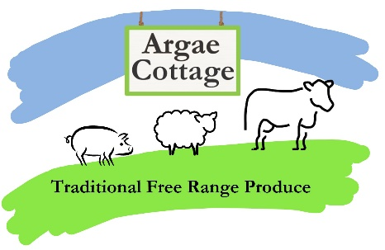

Meat Box Order Form
Name:_________________________________________________
Contact phone number:___________________________________
Email:__________________________________________________

Produce – please tick the ones you require:
Refer to our website for up to date prices and availability.

Grass Fed Beef Box
Free Range Pork: Half Pig Box
Free Range Pork: Quarter Pig Box
Free Rage Pork: Taster Box
Black Welsh Mountain Lamb: Whole Lamb
Black Welsh Mountain Lamb: Half Lamb

If you have any specific butchery requests, or wish to add extras to your order, please add a note here:

Please send your completed form and deposit payment to:
Argae Cottage
Haimwood
Llandrinio
SY22 6SQ

Deposit is usually 50% of order value. Cheques payable to C Benson please.

Or email to: argaecottage@hotmail.co.uk
Payment can be made by bacs: Halifax sort code: 11-07-01, account number: 11343865, account name: C Benson

Thank you for your order!

